**Steps to Setup the Hibernate Development Environment**

1. Download the Hibernate jar zip file from: <http://hibernate.org/orm/downloads/>
2. Extract it to some location
3. Download the Hibernate support JAR files ( mysql-connector-java-5.1.21-bin.jar) & keep it in the above folder
4. Create a Java Project in Eclipse by name “Hibernate”
5. Right click on the Hibernate project, go to “build path” then click on “configure build path”
6. Under “Libraries” tab click on “Add External JARs”
7. Select all the Hibernate & support JARs, click on Open & click on OK

**Steps to Configure Hibernate:**

1. Create a **hibernate.cfg.xml** configuration file under **src/main/resources** (also called as project class path) & provide all the necessary information (Driver Class, DB URL, User Name & Password etc.) of the underlying DB
2. Create the Java Beans which replicates the underlying DB tables
3. Declare Mapping using annotations which maps the Java Bean to DB table & Java Bean properties to DB table columns
4. Add the mapped class to **hibernate.cfg.xml** file.

**Necessary Steps to work with Hibernate**

1. Load the Hibernate Configuration & Mapping
2. Build the Session Factory
3. Open the session
4. Operate with DB
5. Flush & Close the session

**Hibernate Configuration File:**

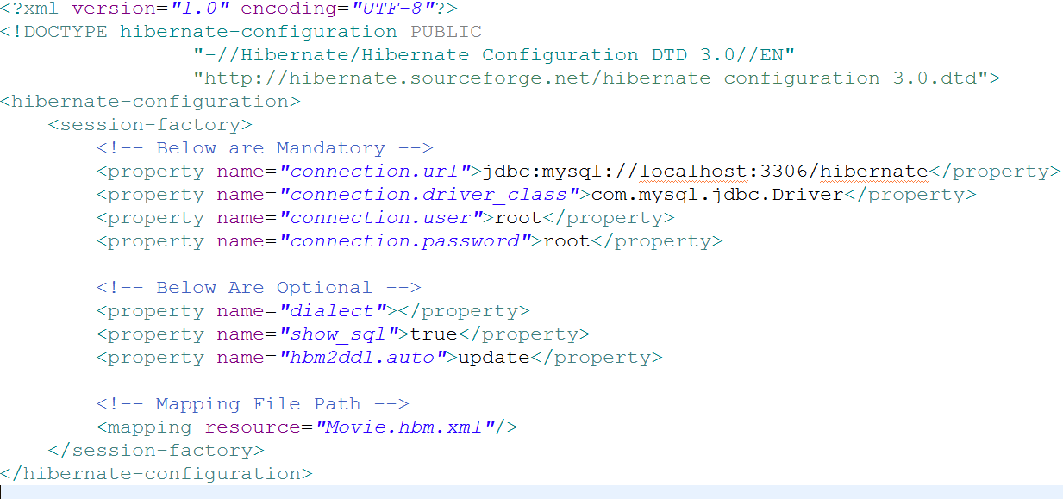

**Movie.hbm.xml File**

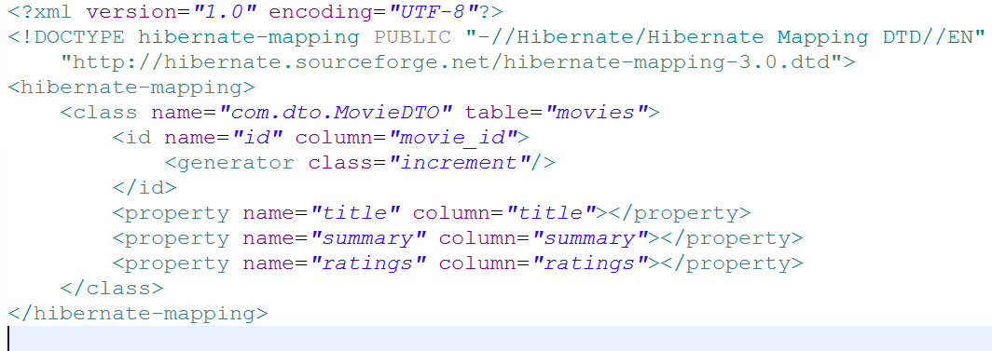

**Hibernate Program:**

